Output May 18, 2016

Conceptual directed diagram (digraph) of the Salish Sea in relation to survival of salmon (taken here to be Chinook, Coho, Steelhead). Model compartments (ovals or rectangles) represent biomass pools, ecosystem drivers, and traits of interest. Lines with arrows show positive relationships; lines with filled circles show negative relationships. Small negative loops on model compartments represent self-limiting functions.

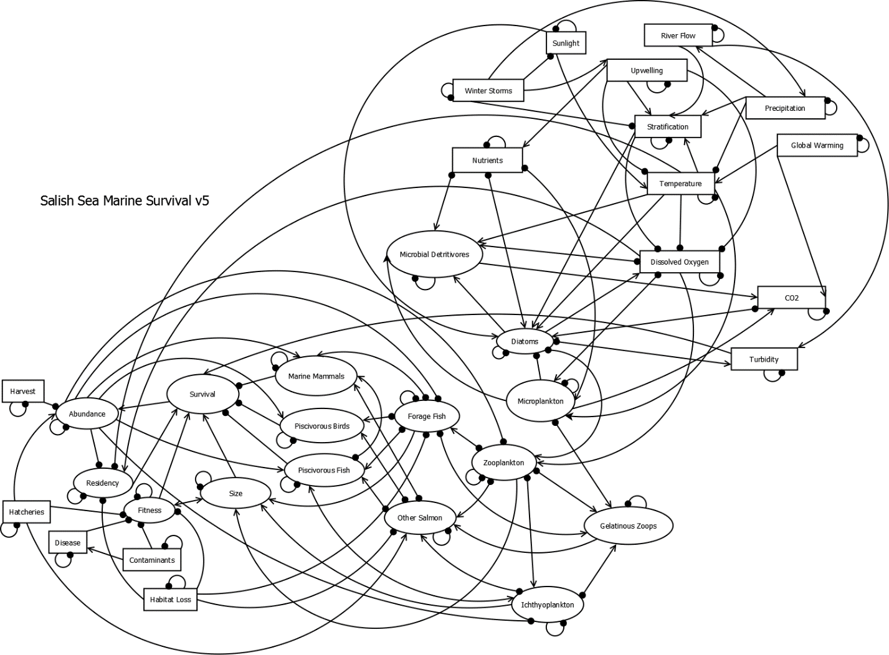

This version of the model is different from previous versions in that:

-It has a disease node

-The mixing node has been removed

-The bi-directional arrow has been restored between Fitness and Size

Scenarios for Basin-Level Effects

|  |  |  |  |  |  |
| --- | --- | --- | --- | --- | --- |
| **South Sound** | Perturbation | **Hood Canal** | Perturbation | **General Basin** | Perturbation |
| Temperature | ↑ | Stratification | ↑ | Temperature | ↑ |
| Gel. Zooplank. | ↑ | Dissolved Oxygen | ↑ | Diatoms | ↓ |
| Nutrients | ↑ | Turbidity | ↑ | Gel. Zooplank. | ↑ |
| Forage Fish | ↓ |  |  | Forage Fish | ↓ |
| Habitat Loss | ↑ |  |  | Marine Mammals | ↑ |
| Contaminants | ↑ |  |  | Habitat Loss | ↑ |
| Hatcheries | ↑ |  |  | Contaminants | ↑ |
|  |  |  |  | Hatcheries | ↑ |

Output for Scenarios:

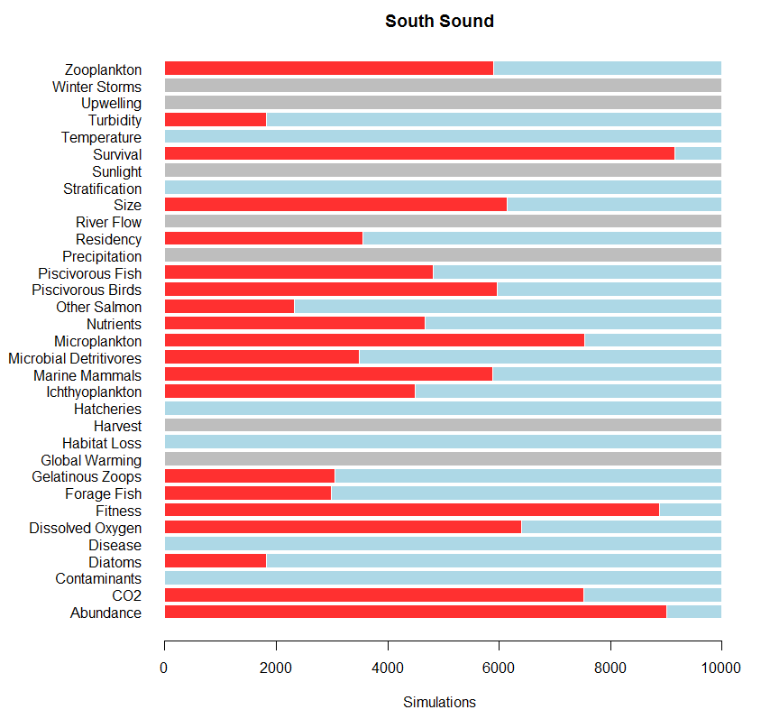

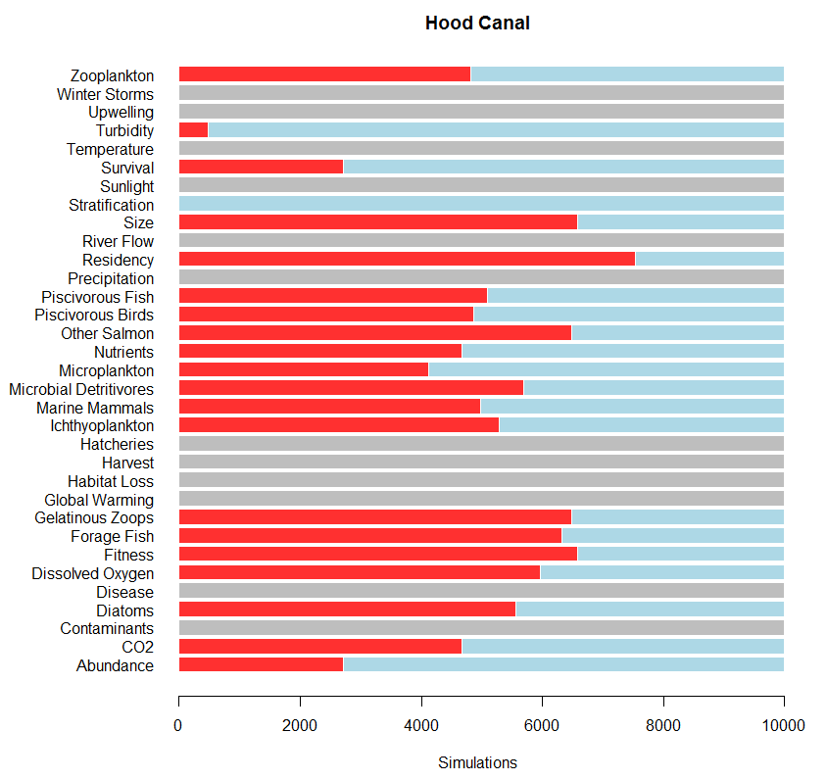

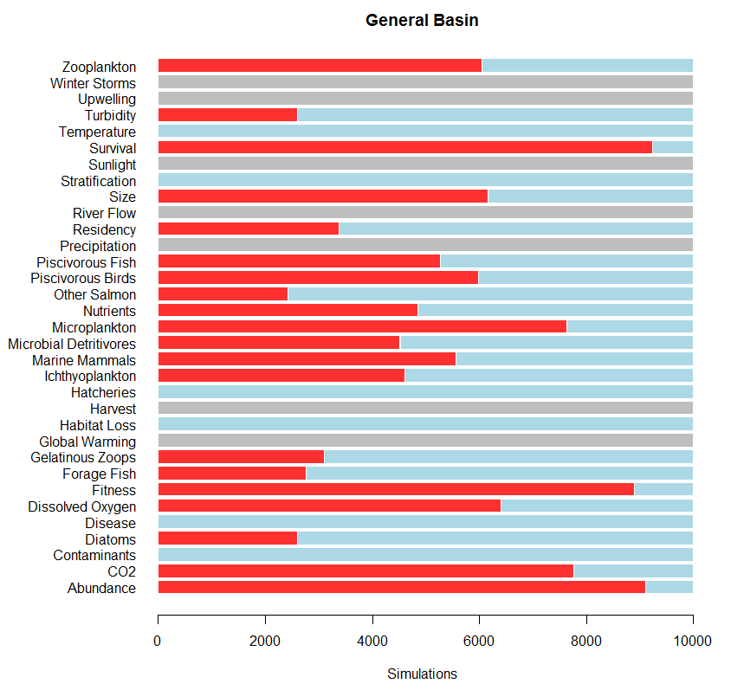

Summary of Scenarios:

* Survival is lowest (most negative in General Basin and South Sound Scenarios), much higher in Hood Canal. This seems to reproduce the actual trends.
* Other Salmon do well in SS and GB, but not as well in HC, where about 60% of the models show a negative response.
* Residency response is mostly negative in Hood Canal, but positive in the other two scenarios.
* Fitness is negative in GB and SS scenarios.

Outputs for single perturbations for 6 selected nodes:

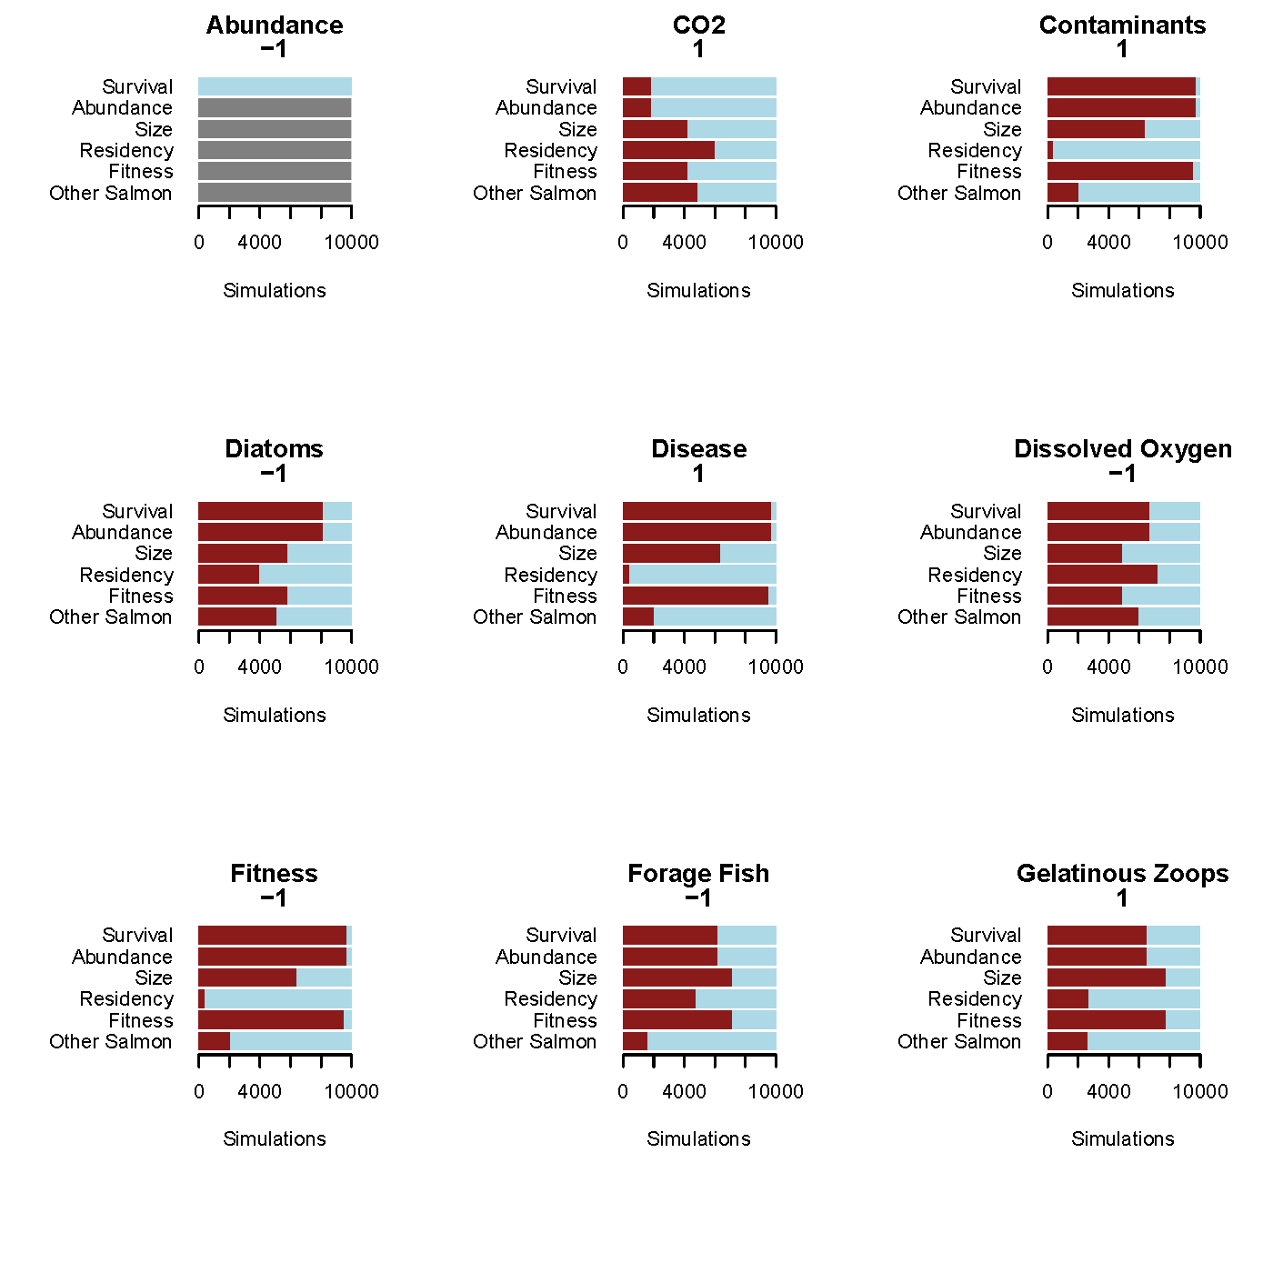

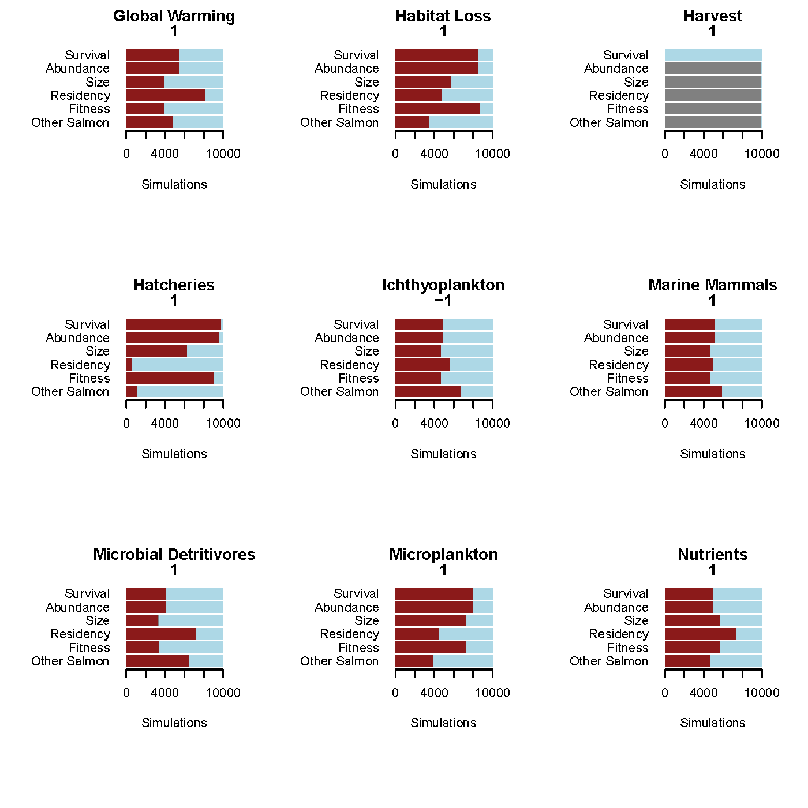

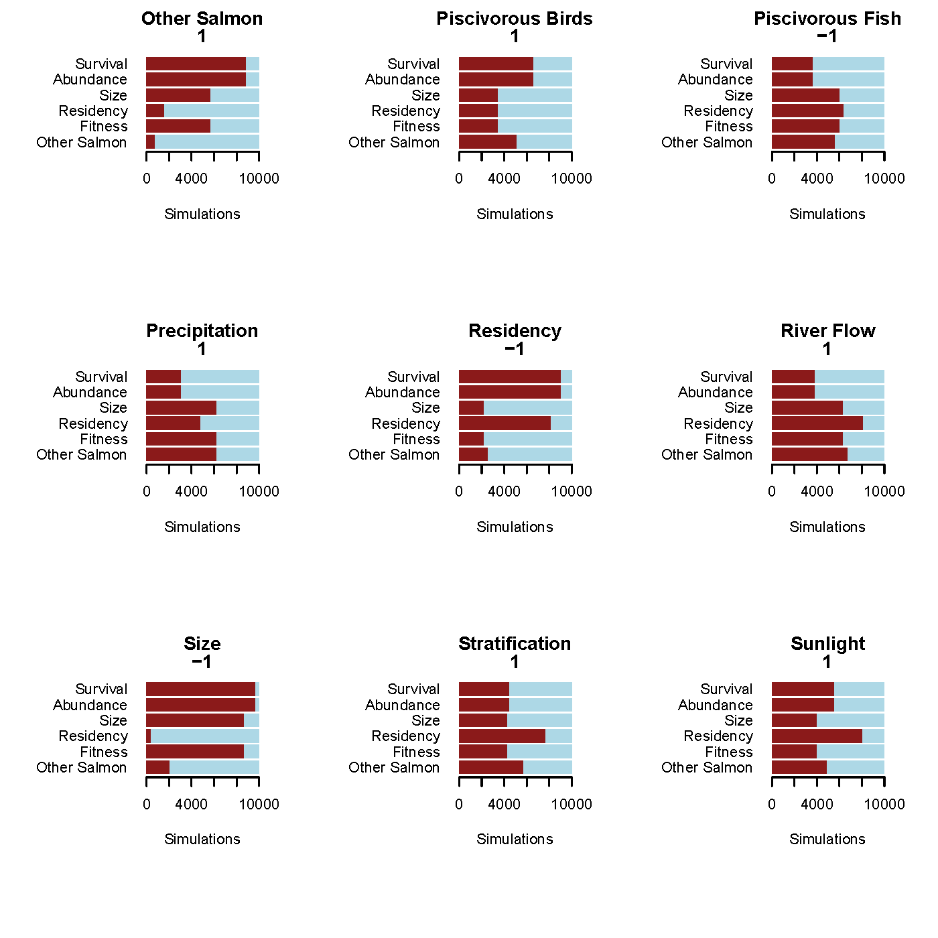

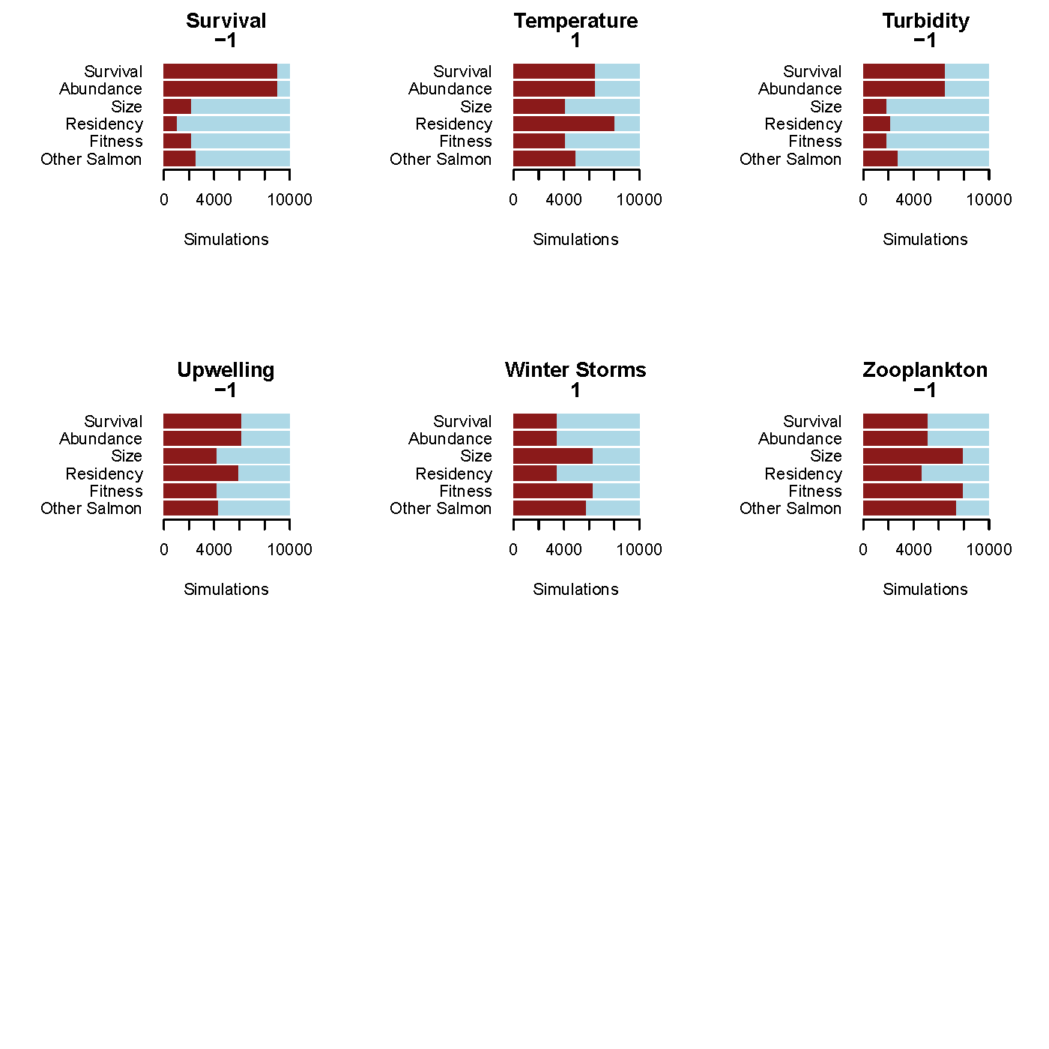

Summary Indiv. Perturbations:

* A decline in some meso-level foodweb components (zooplankton, forage fish) have across the board moderate to strong effects.
* Low-trophic level nodes also have strong negative effects (microzooplankton, diatoms, gelatinous zoops.).
* Direct effects (habitat loss, contaminants, disease) have strong negative responses, but some oceanography components—which are further removed from the nodes of interest—also have strong negative responses (dissolved oxygen, nutrients, temperature)
* Puzzling that the abundance/survival and harvest/survival interactions are contrary to hypotheses, but it likely has to do with feedback loops